Dis-Eur-Female Figurine-Bulgaria, Stara Zagora

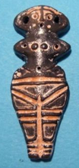

**Formal Label:**

**Accession Number:**

**Date or Time Horizon:** 6th millennium BCE

**Geographical Area:** Stara Zagora, Bulgaria

**Cultural Affiliation:** Neolithic

**Medium:** **terracotta colored with charcoal and red ochre Fe2O3.**

**Dimensions:**

**Weight:**

**Provenance:** Archaeological Museum in Stara Zagora

**Condition: Museum Replica**

**Discussion:** These figurines date to the beginning of farming in central Europe and their red ochre geometric markings probably emulated the shape of tattoos or body paint.

**References:**